Let’s all Dispose Of Fats, Oils & Grease (FOG) Properly
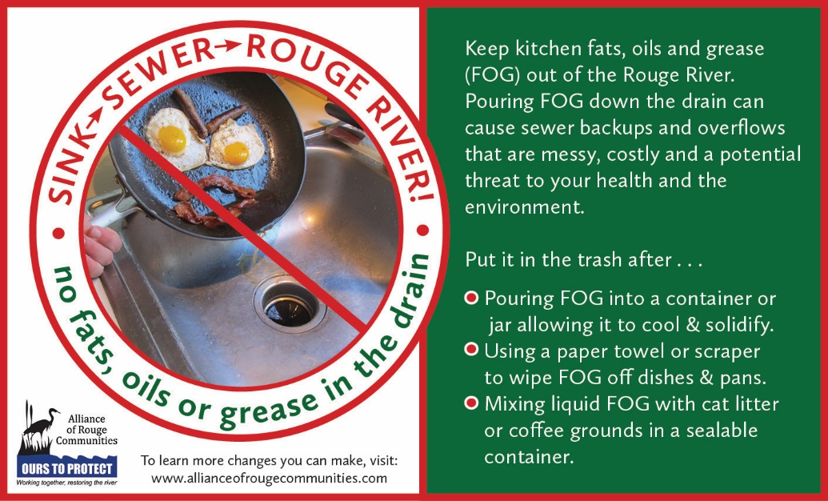
Never pour kitchen fats, oils and grease (FOG) down your sink drain. Pouring or washing FOG down your kitchen drain can build up and block pipes which is costly to you and the Rouge River. FOG enters sewer pipes through restaurant, residential and commercial sink drains. Once in the sewer, FOG sticks to the inside of the pipe, thickens, and can eventually block the entire pipe.

Blockages in sewer pipes can send sewage backwards and up through floor drains and toilets into homes or businesses, and/or out of manholes into streets and rivers. These sewage overflows pollute our homes, businesses and our environment. Cleanup costs can be expensive, and the cost can be much higher if your home has a septic system.

Preventing sewer backups from FOG blockages saves residents and business owners money and protects the water quality of the Rouge River. Residents and business owners can help control the problem by properly disposing of fats, oils and grease.

Practice and share these healthy habits with your family, friends, and neighbors:
- DO pour or scrape greasy or oily food waste into a container or jar and allow grease to cool or solidify in the container before throwing in the trash.
- DO use a paper towel or a scraper to remove residual grease from dishes and pans prior to washing.
- DO mix liquid vegetable oil with an absorbent material such as cat litter or coffee grounds in a sealable container before throwing it in the trash.
- Do keep drains clean by pouring 1/2 cup baking soda down the drain followed by 1/2 cup vinegar, wait 10 to 15 minutes and then rinse with hot water.
- DO NOT pour fats, oils or grease down drains or garbage disposals.
- DO NOT use hot water to rinse grease off cookware, utensils, dishes, or surfaces.
- DO NOT put ‘disposable’ wipes down a drain or toilet - they do not dissolve and will cause clogs.

FOG buildup in sewer pipes requires your local public works staff to go to the site and remove the blockage. Cleaning FOG buildup from sewers increases maintenance costs for you and everyone else in your community. Keep our environment clean and avoid unnecessary maintenance costs by keeping fats, oils and grease out of our sewers. For more healthy habits you can practice at home or work to protect water quality in the Rouge River, visit www.allianceofrougecommunities.com/watershed.html .

